East Midlands lifters at the World Masters
The East Midlands was a significant part of the masters team that went to the IPF World Masters championships in Ostrava, Czech Republic. The East Midlands lifters were Jenny Hunter, Allen Ottolangui, Steve Walker, Mick Amey, George Leggett and Doug D’Gama.

Here is Doug getting a helping hand from his lifelong hero Brad Gillingham and he’s wondering if he’s big enough for Powerlifting after all!

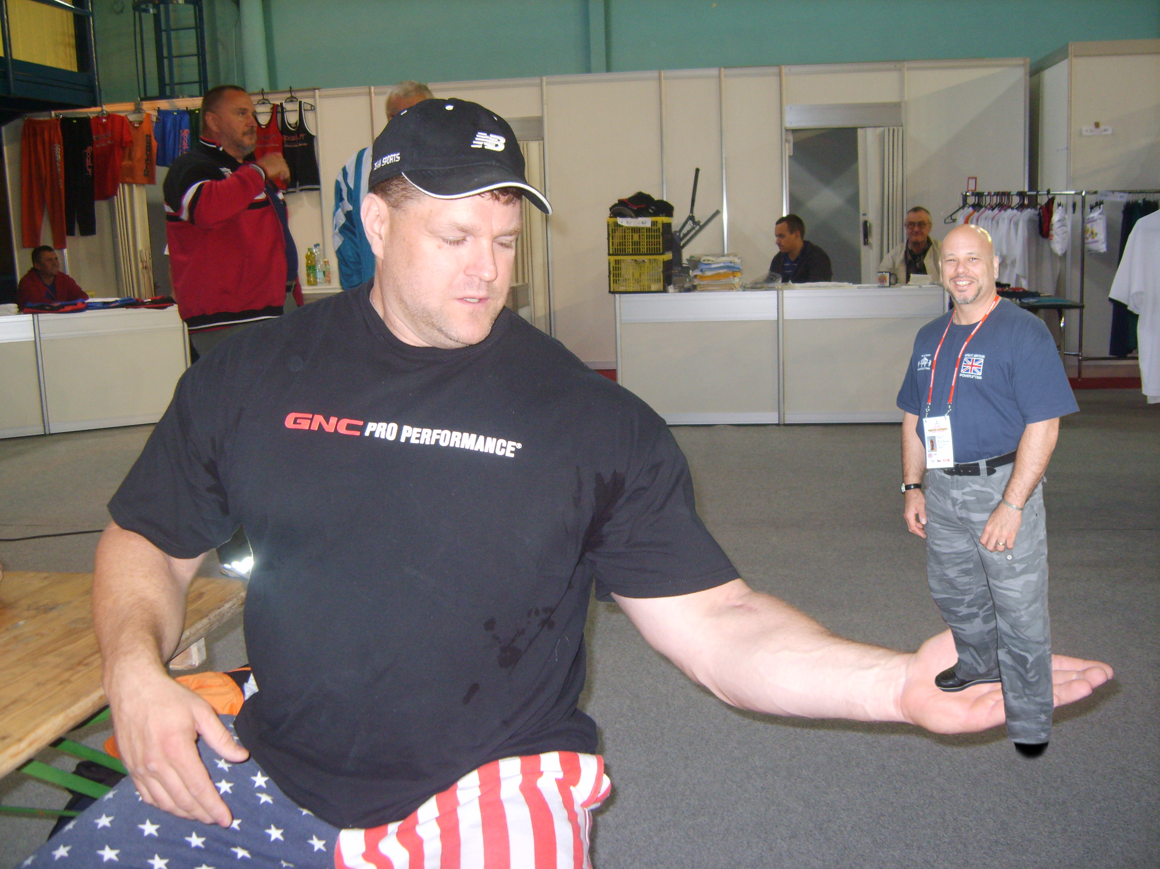

A full report [and photos] on the exploits of the East Midlands at the world masters appears later in this newsletter provided by and with thanks to Steve Walker. [See page 4].

News in brief

East Midlands Divisional Championships
These are scheduled for the 29th November in Letchworth. All support welcome and let’s look forward to a great finish to the years competitions in this division.

IPF World Masters Championships
Czech Republic, September 2009

A strong British team entered these championships with a significant East Midlands contingent [see later report by Steve Walker]. Full results can be found from the IPF website by following this link: http://www.powerlifting-ipf.com/World-Masters-Powerlifting.263.0.html.

EPF Masters Bench Press Championships
Belgium, October 2009

I travelled as team manager for this event with 9 masters lifters, and we returned with 5 medalists included our own James Jeffries as the latest European champion from the East Midlands. The team managers report has been included later in this newsletter [see page 12] and full results are available on the EPF website or by following this link: http://results.powerlifting.org/?eventid=2009BEl1.

IPF World Championships
India, November 2009

Despite a mix up over the visa’s and some of the team not being able to rectify this and travel, we still have a new world champion in Dean Bowring. Full results are available on the IPF website by following this link: http://www.powerlifting-ipf.com/World-Men-and-Women.266.0.html. An interview with Dean was done for local BBC television in the South and this can be seen on the BBC website, a link is available from the latest news on the GBPF website: www.gbpf.org.uk

Provisional competition calendar
The calendar of competition and other events for next year has been appended for general information. These dates (for GBR) have yet to be fully ratified by the GBPF executive but are unlikely to change at this stage.

The calendar also includes international events and should assist in planning of divisional events for next year, as well as your own training and preparation. [See page 14]

EM committee meeting
Minutes of latest meeting included in this newsletter. [See page 7]. Note: the next committee meeting is now scheduled for the 29th November 2009 and not as originally planned.

IPF technical news bulletin no 4/2009 and 5/2009
The IPF technical news bulletin produced in August 2009 contain details of a technical briefing to be used by IPF referee’s ahead of each class in world championships. For the sake of consistency of refereeing I have included the bulletin with this newsletter, or alternatively it can be accessed on the IPF website: www.powerlifting-ipf.com. [See page 8].

Calendar
Date | Competition | Venue | Details
29 Nov 2009 | Divisional Powerlifting Championship | Hitchin WLC Letchworth | Equipped

Contacts
EM Powerlifting Association – committee members
Name | Position | Telephone | e-mail
Dave Tucker | President | 01223 411414
Pete Weiss | Chairman | 01604 844669 | peter@pweiss.wanadoo.co.uk
Jenny Hunter | Treasurer | 01223 479511 | jenny@ced.co.uk
Kevin Jane | General Secretary | 01327 312535 | Kevin@kjane.fsbusiness.co.uk
Ian Kinghorn | Newsletter Editor | 01295 760172 | Ian.kinghorn@bcs.org
Ian Kinghorn | Records Officer | 01295 760172 | Ian.kinghorn@bcs.org
Ian Kinghorn | Membership Registrar | 01295 760172 | Ian.kinghorn@bcs.org
Kevin Jane | Drugs Liaison Officer | 01327 312535 | Kevin@kjane.fsbusiness.co.uk
Kevin Jane | Child Protection Officer | 01327 312535 | Kevin@kjane.fsbusiness.co.uk
Dave Tucker | Technical Officer | 01223 411414
Pete Weiss | Asst. Technical Officer | 01604 844669 | peter@pweiss.wanadoo.co.uk
Pete Weiss | Powerlifting Secretary | 01604 844669 | peter@pweiss.wanadoo.co.uk
Stuart Hamilton | Web site Manager | 01206 854319 | hamiltonsfitness@aol.com
Allen Ottolangui | Committee Member | 01462 675952 | aacj38@yahoo.co.uk

East Midlands lifters at the IPF world Masters Powerlifting Championships
With thanks to Steve Walker for report and pictures.

After a 3.00am start on Sunday morning with flights to Prague and then down to Ostrava in a propeller driven jet we arrived in our hotel opposite the venue by early afternoon with time to rest up check out the venue and our bodyweights.

First off on Monday was Jenny Hunter down to the 52Kg class for the first time in many years and up against German, French and American competition. A faultless 3 squats, 3 benches and 2 deadlifts and a winning total of 367.5 kg meant that Jenny didn’t need to take a 3rd deadlift and won gold medals on all 3 lifts and overall gold winning by 52.5 kg – a fantastic start.

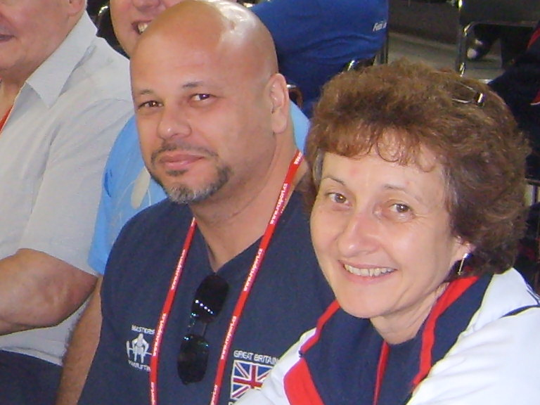

Unfortunately Jenny picked up one or two nasty hobbits in the Czech Republic!

Tuesday was manic to say the least with 5 GB lifters all going in the 75kg division in various age groups including 4 East Midlands lifters – Allen Ottolongui M1, Steve Walker M2, Mick Amey M3 and George Leggett M5.

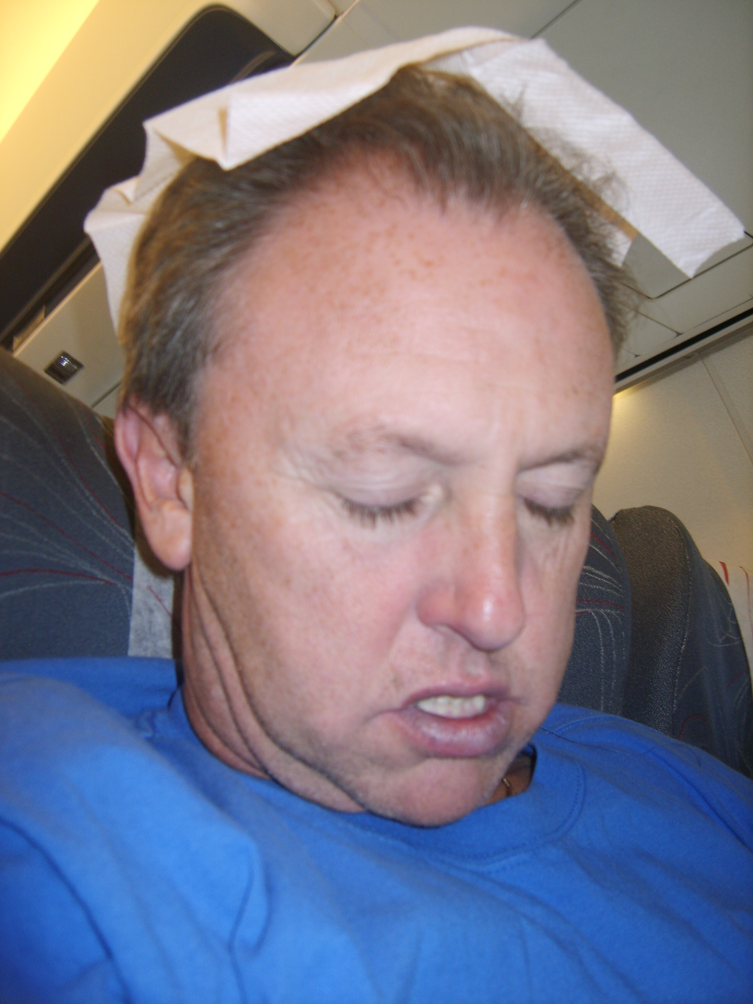

Allen taking the no mandatory Masters ‘pre lift nap’. Note the anti dribble serviette just in case

Allen, soon to enter the Masters 2 age group was up against at least two 700kg total lifters and had his work cut out. Squatted well for 250kg, benched 145kg and deadlifted 235kg for a 630kg total and 4th place which considering his dying fly routine [see picture below] on the opening deadlift was a good total for him although it was probably around 20kg down on his target for the day.
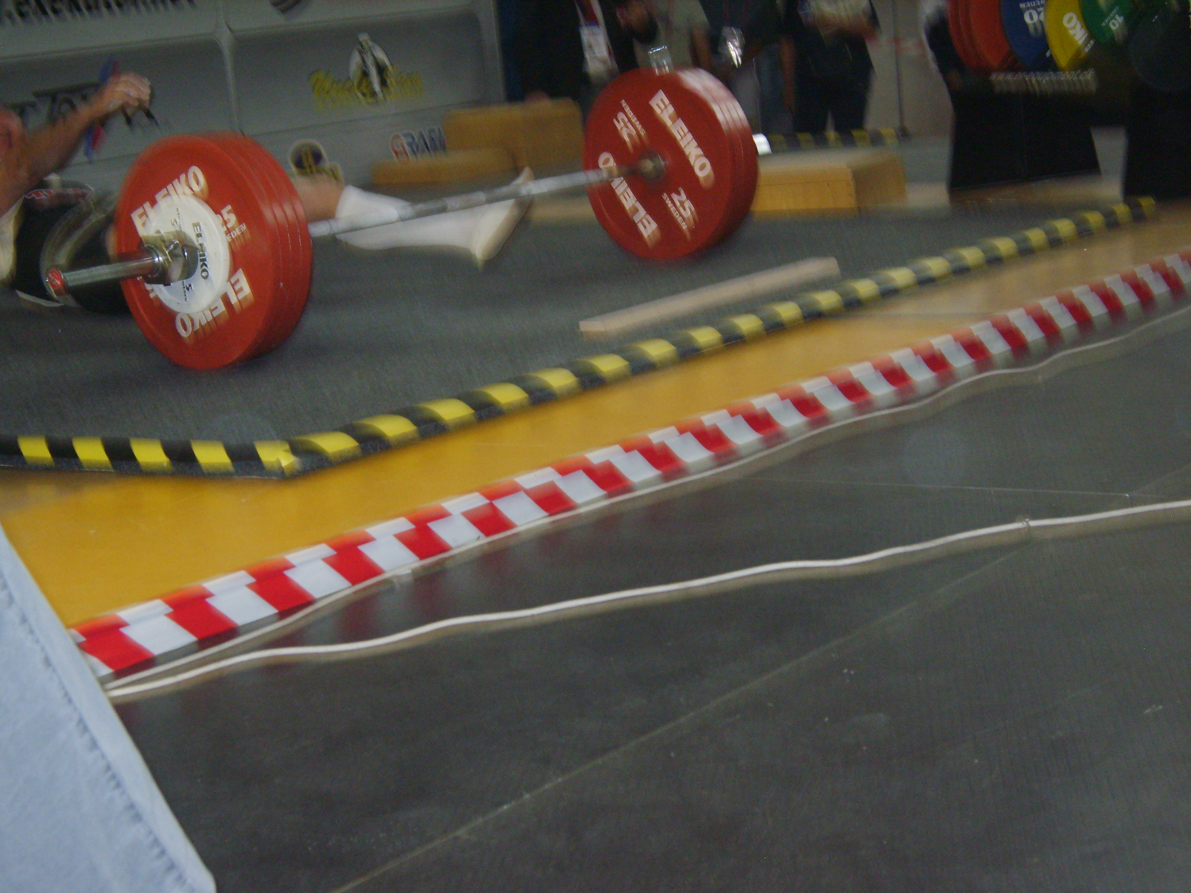

Despite a huge British appeal to the jury, Allen’s opening deadlift unbelievably picked up 3 red lights

Steve Walker was in a class of 9 lifters with a Russian and Czech lifter moving down from the 82.5kg class on the morning. Squatted 237.5kg, benched 170kg and deadlifted 247.5kg for a 655kg total for the overall gold medal and a win by 45kgs. The other contenders had some big individual lifts but lacked the consistency needed on all 3 lifts.

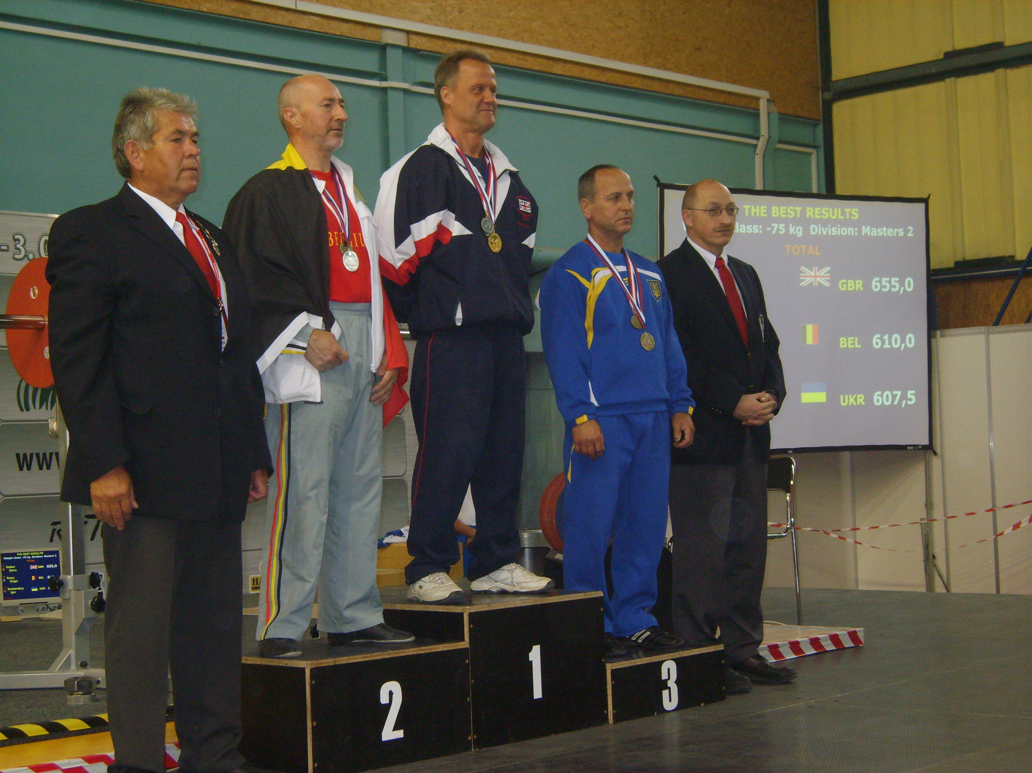

Some people say Steve only got his gold medal because the other two were delayed in changing their colostomy bags!

Mick Amey was fired up after his European Masters gold earlier in the year and had been planning to take gold here but always knew that if the Japanese legend Toshihiko Sato (not now Sato!!) was anywhere near his normal form then winning would be nigh on impossible and so it proved.

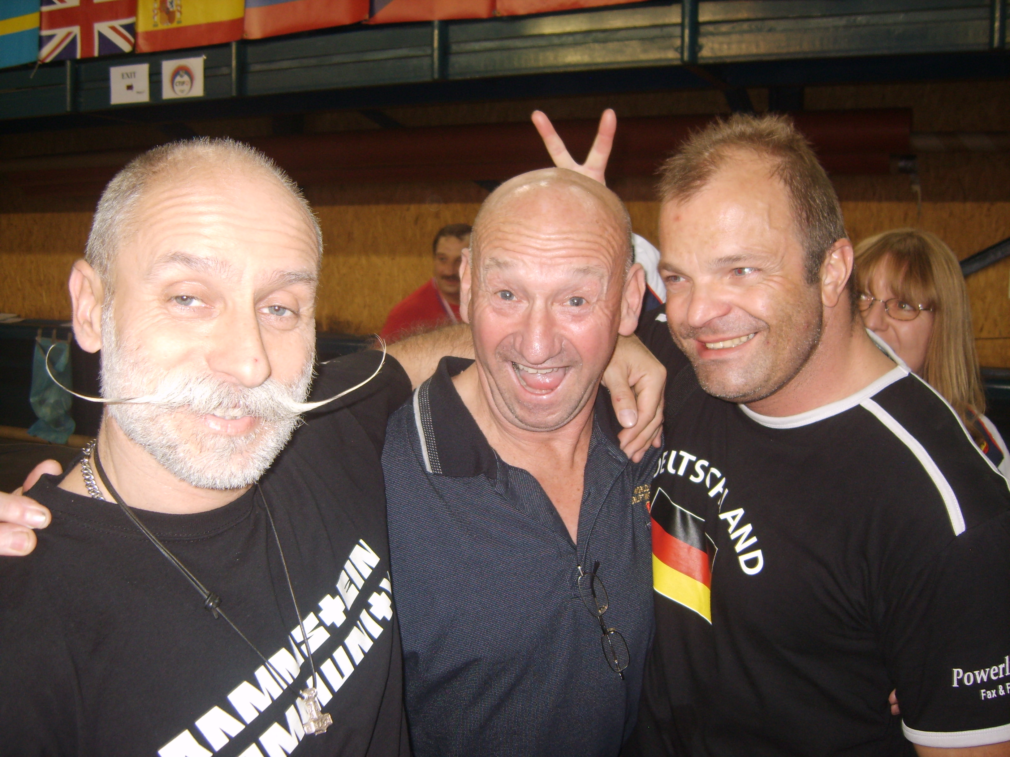

Mick had mentioned the war but got away with it by looking stupid

Mick squatted 210kg for bronze, benched 112.5kg for bronze, deadlifted 225kg for bronze and totalled 547.5 for overall silver – a terrific effort on a World stage. Sato, at 69 years of age totalled 610kg – an amazing achievement and we promised Mick we would kidnap him before next years Worlds!

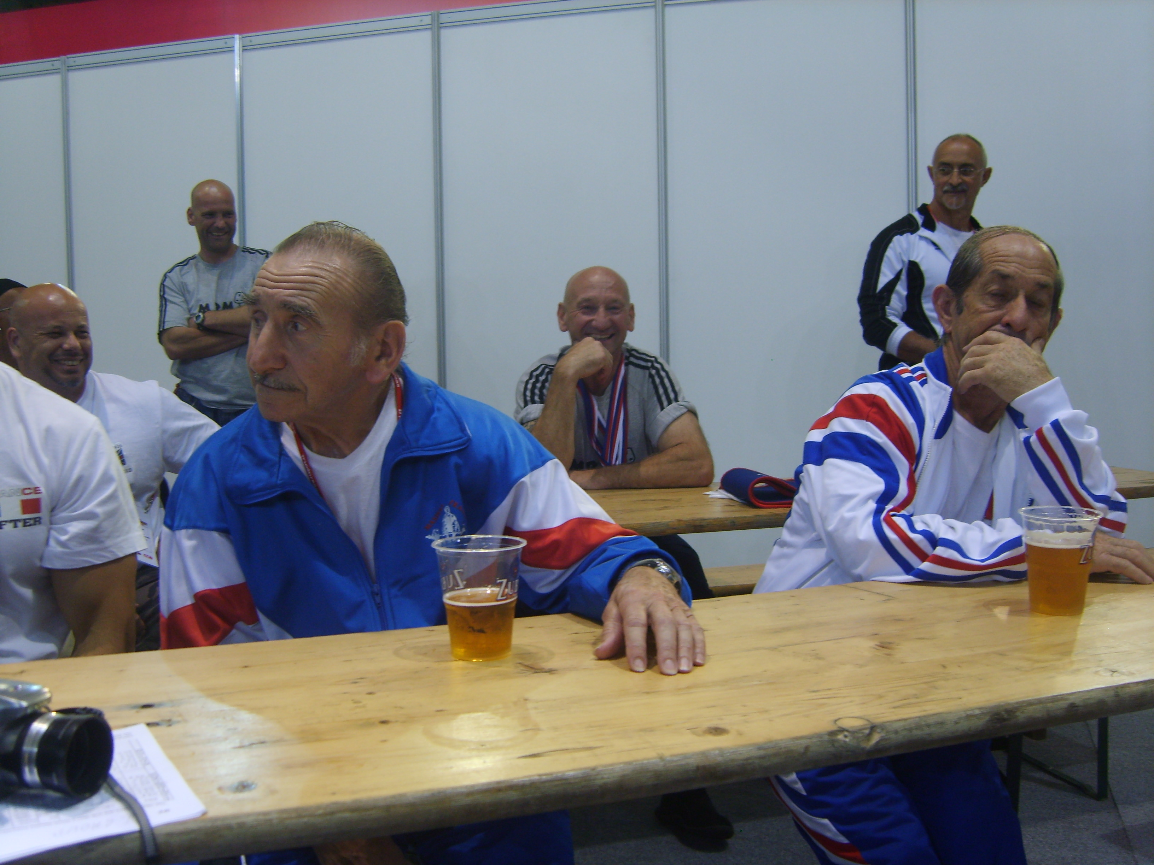

Mick Amey spent most of his spare time catching up with his two younger French brothers

Finally, our own legend, George Leggett lifted as consistently as ever with a 180kg squat, 82.5kg bench and a 180kg deadlift for a total of 432.5kg and overall 8th place in Masters 3. Considering that George is now 80 years of age and really a Masters 5 lifter this was also an incredible achievement and if George gets his way with the IPF and they do create a Masters 4 & 5 divisions then he will most definitely be World Champion.

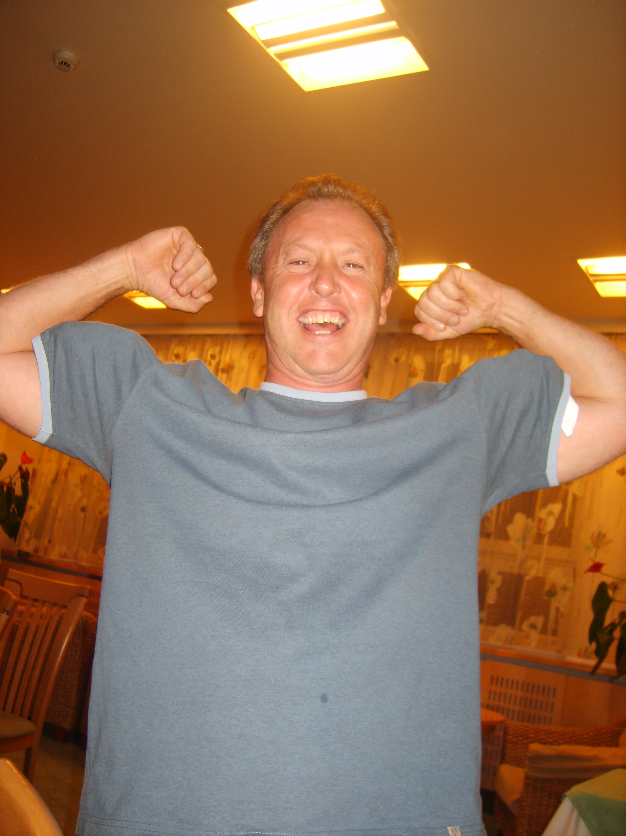

Jealous of all the girls having bigger arms than him, Allen “baby biceps” Ottolangui resorted to foul tactics at every opportunity.

The last East Midlands lifter to go on Thursday was Doug D’Gama in the 90Kg Masters 1 class. This was Doug’s 1st ever Worlds and he has only been powerlifting for 3 years previously being a kick boxer for some 20 years.

Despite being very nervous Doug lifted well, squatting 235kg (only just missing 245kg on depth) benched 175kg and deadlifted 252.5kg for an equal personal best total of 662.5kg and 8th place – a great result for such an occasion and valuable experience for him to continue to build on.

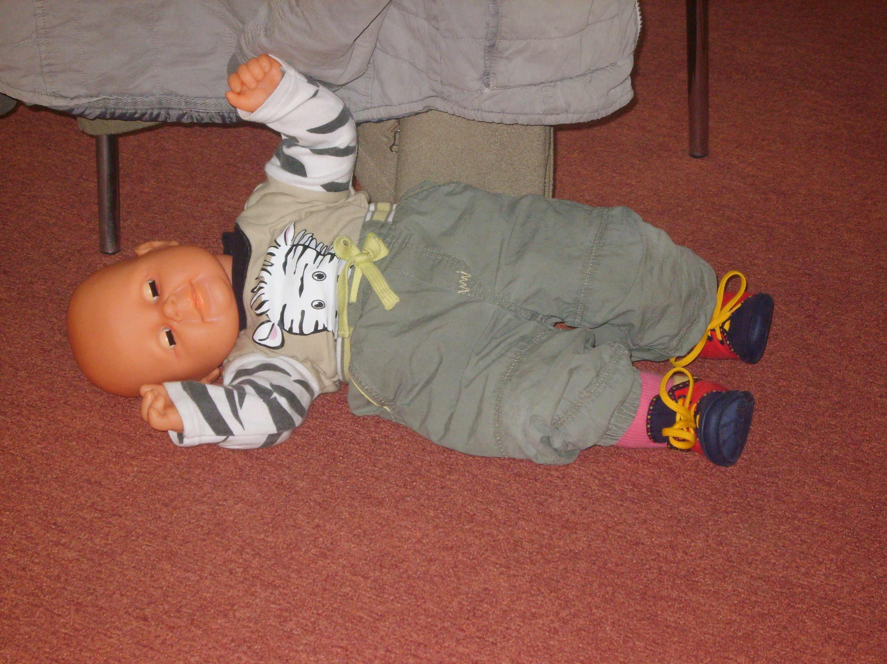

Rumours of a “Mick amey love child” were rife at the venue!

So the East Midlands lifters can be proud of a great team effort with superb individual performances, a lot of happy times, some great memories that become the stuff of legends (Allen’s deadlift) and a problem free trip.

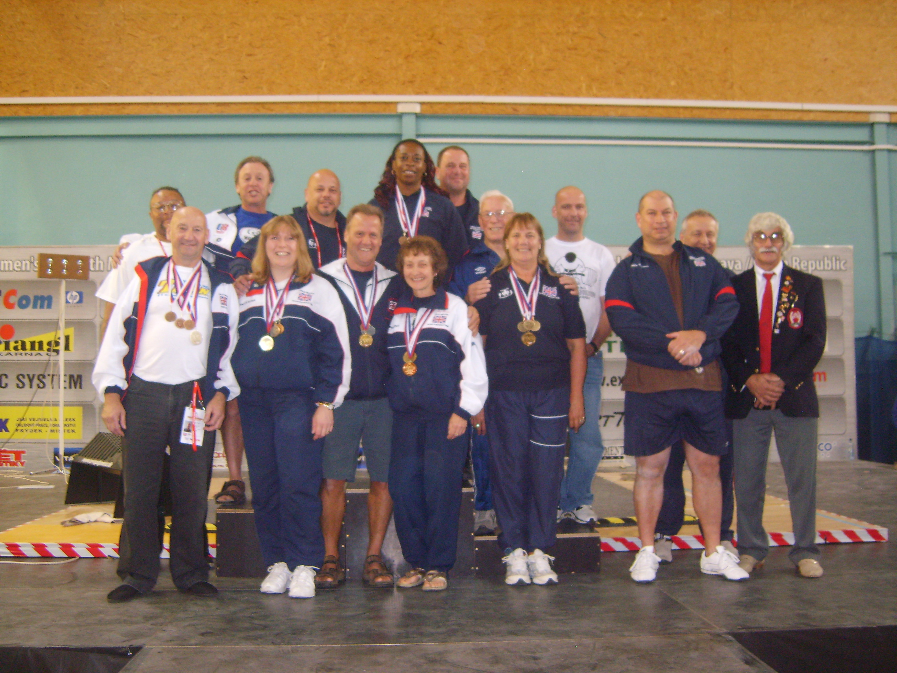

The GBR team (and Allen)

Finally, a very special thanks from all the lifters to Ashley Amey for his help in the warm up area, not just to Mick and all the East Midlands lifters but to the entire British team.

East Midlands Committee Meeting
The East Midlands Powerlifting Association – Minutes of committee meeting held on Saturday 15th August 2009 at the Hitch WLC, Letchworth.

Meeting opened at 10.35am
Members present; Peter Weiss, Allen Ottolangui, Ian Kinghorn, Jenny Hunter, Dave Tucker, Stuart Hamilton, Kevin Jane.
Matters arising from previous meeting (4/4/09)
- Dave Tucker expressed his concern that only one person (Steve Jones) out of several people who had indicated that they intended to take a divisional referees exam did so. This was despite some financial help being on offer if applied for.
- Allen had e-mailed Steve Walker to see if he was interested in taking on a role as fundraiser for the division, he is still awaiting a reply, as Steve is on holiday.
- Dave Tucker said that his application for an award for Jackie Blasbery was still under consideration. If not successful it was suggested that alternative awards could be sort.
Treasurers Report; Jenny informed the meeting that that account currently stands at £2,204 + £24 now received from the Farm PLC and a further £106 to come from Hamilton’s Fitness Centre.
Dave Tucker forwarded an expenses claim for £56 which was honoured. Because of the limited amount of divisional funds at present it was agreed that officers expense claims should be presented at each meeting and a maximum of £100 per year per officer be enforced. Larger amounts will have to be approved by this committee.
All England Championships; Referees present had not been contacted by Fred Sterry to date regarding officiating at the event – the Secretary will contact Fred ASAP.
Ian Kinghorn has offered to loan the bench/squat stands from the Yardley Gobion club.

A.O.B.
I. The Secretary reported that he had received a letter from John Jackson the week after the national championships.
The letter made accusations that despite being elected as a merchandising officer for GBPF the Divisional Secretary had not permission to use the GBPF logo and was making profit for his own business. The matter had been raised with Arthur Hoey and a request to John Jackson for a written apology had been made.
ii. Ian Kinghorn has indicated that he wishes to provide a trophy that can been awarded each year to a lifter who in the opinion of the committee meets specific criteria to be decided upon at the next meeting.

111. The committee decided that an order should be placed for 30 embroidered T-shirts with the GBPF logo and divisional name on for retail.
iv. Ian Kinghorn will include a preliminary list of competitions for next year in his next newsletter + IPF technical bulletin No.4, Ian will also send the latest list of divisional records to Stuart Hamilton to post on the web site.

Meeting closed at 11.50am Date of next meeting Saturday 7th 2009 at 10.30am Hitchin WLC Letchworth

IPF technical newsletter (no 4 and 5)
TECHNICAL NEWS BULLETIN NO 4 2009

Bench Shirts
There was much controversy at the 2009 Open Bench Press Championships in regard to Bench Shirts, some that had been "doctored" to the extent that they did not resemble the shirt that was sent by the manufacturer for approval by the Technical Committee. Unfortunately in one instance, two shirts passed the scrutiny of the gear check but were later discovered to be illegal, and in another instance, shirts eventually found to be legal had been rejected at gear check.

To be clear:
To adjust for better fit alterations may be made in the tightening of the shirt, but only on the original seams. (PERSONAL EQUIPMENT (g)). Although alterations/pleats to form a tightening of the suits and supportive shirts do not make them illegal, these must be made on the original seams). The method advised is a "gathering" of the excess material.

The origin of this concession was to allow lifters to buy large, tighten, and let out as they no doubt gained body-weight.

The sleeves, should they extend below the elbow may be cut and re-sewn. There shall be no alteration or tampering made to any other area, specifically to that of the neckline or chest.

Suits (IPF Legal)
Lifters must take care when purchasing equipment that it conforms to IPF regulation. At the recent World Games a deadlift suit was rejected because of seams in the legs that were purely designed as a reinforcement or bracing. There are costumes that look similar from the same manufacturer but are designed for other organisations where the rules on supportive gear are not as stringent as that of the IPF.

Referees (Examinations)
Congratulations to the following that recently passed the International Exam.
Category 1
Laura Locatelli Italy
Category 2
Ivan Cancel Puerto Rico
Karen Licciardi USA
Tony Nicolini USA
Alexander Gorohovskiy Russia

Squat
I have been asked to mention that stepping back after the "rack" signal is not cause for failure. Apparently some referees are still not aware of this although clarification has been made in many dispatches.

Rules Congress
My apologies for informing all that Rules Congress is 2010. It is in fact 2011. Proposals forwarded by the Technical Committee maybe deferred for discussion by the Executive Committee perhaps nearer this time.

Logos
It has been entered into the Technical Rules that manufacturers emblems may accompany the accepted logo and do not need to be masked.

World Games
Although it is not my duty to report on the World Games. On behalf of the Technical Committee I would like to thank the Taiwanese Federation for their second to none hospitality shown throughout this most prestigious well organised meet, and to the selected referees who all enjoyed the experience.
Platform Referees (Briefing)
With the recommendation of the Technical Committee and acceptance of the Executive Committee, in future, at all World championships a Referee's Briefing will take place fifteen minutes before lift-off for each and every class. These short but specific instructions do not replace the more comprehensive clinic. There is much more to being a knowledgeable referee than pushing buttons on a key pad, especially when a Cat 1 is asked to sit on a Jury. All aspects of the Technical Rules should be known. Relying on others knowledge is not good enough.

It is unbelievable to still receive E-Mail and calls from some International Referees who appear to have not kept abreast with the rules over the years.

John Stephenson
Chairman IPF Technical Committee

Technical Committee News Bulletin No 5 2009
World Sub-Junior/Junior 2009

Reflections

It was rewarding to have been invited to the 2009 World Sub-Junior/Junior Championships held in Sao Paulo – Brazil. A near perfect meet under the direction of Eumenes L. Souza and IPF board member Julio Conrado.
I will not offer an account of the lifting or results, this is the duty of other personnel, but some observations made may be of interest and food for thought in regard to future competitions.

At the Technical Meeting the referee’s names were/ are announced from the final list of nominations, and whether they are present, or will be available for duties that have already been allocated and posted.

The referee’s names forwarded to IPF Competition Secretary Gaston Parage must include the weight classes that they are available for. This is the only way that a reasonably conclusive schedule can be formulated. It is frustrating when some referees who have nominated themselves for ALL, that they then make lame excuses for declining. I am not just referring to this particular championships, it happens at all except the World
Games.

Many times I have told the tale of two referees who were to attend a weigh-in at Bill Jamison‟s Marathon World Meet in Hamilton – Canada. The contestants were waiting to weigh and I was called, for only one referee was present. After a search it was discovered that the bus which stopped outside of the venue took a direct route to the Niagara Falls. By coincidence the bus was just pulling away as I peered out of the venue door. I am sure that it was the two (AWOL) referees who were waving goodbye and going sight seeing.
It may seem laughable now, but it was damned annoying at the time. Should referees not be available for the whole of the meet, please do not put ALL on the nomination form.

The now compulsory, approximately ten minute rules briefing for referees in each of the classes prior to sitting on platform has proved to be of value, for the judging appears to be of a higher standard, and certainly more uniform.

Some chaos was caused because of an early opening of the scales (by five minutes). Lot number one decided that there was time to visit the toilet before the scales opened and his name being called. He returned to find that lot number three was weighing in and his name had been transferred to the bottom of the list. This was corrected. Because of incidents such as this the scales must open on the exact time as that announced at the
Technical Meeting.
It was brought to my attention that a male official was present when one women‟s class was weighing in.
When the women weigh-in at least two lady officials from different nations (not necessarily IPF referees) must conduct the weigh-in. It is not acceptable for a male official to conduct a women‟s weigh-in at IPF World Championships. Likewise, the same should apply to that of men i.e. weigh-ins must be conducted by the same sex as that of the competitors.

On three occasions in the squat lifters un-gripped the bar when asked to “rack” letting it fall amongst the spotters. Both lifters and coaches were reprimanded for this dangerous display. Should a lifter do this on two attempts, then it will definitely be a disqualification.

I recall sitting in the chair at the 1980 Worlds in Arlington – Dallas when the championships were held up for a length of time while paramedics attended to, and finally took to hospital a spotter who suffered a suspected thigh fracture after + 400 kg had been dumped.

A question asked by a referee was „can he as Chief Referee tell the lifter to e.g. lock the legs if it is obvious that this is the reason why he is not receiving the “squat” signal without awaiting the five seconds to be told “replace” the bar‟. Yes, why not, especially in regard to Juniors. Referees must show some understanding.
If there is a language barrier, a gesture is often adequate.

On the subject of language I was amazed when told that a referee who had been selected as Chief, declined because he could not speak or understand English. This is worrying, for there are only six commands in English – Re-place, Squat, Rack, Start, Press, Down. Is it customary to use commands in ones own language at National Events?

Having observed the lowering or dropping of the bar by Sumo style dead-lifters and how dangerously close it came to removing their toes on many occasions, the Technical Committee have proposed that allowable lateral foot movement which may compound the danger, be re-moved from the Technical Rules. The rule was felt necessary in the days when lifters had to contend with slippery platforms. Now that the surface must be of non-slip carpet the rule is unnecessary.

Bars

Because the rule says that all bars manufactured since 2008 and their manufacturers wishing them to be “IPF Approved” must have the same knurling distances, this does not mean that bars which received IPF Approval before this date are not legal. They are perfectly legal! The only difference being – Bars used for IPF World Championships must conform to that as illustrated within the IPF Technical Rules. The reason being, that the bar is not felt alien to overseas lifters, the grip being the same as that of which they are used to.
Retirements

The Technical Committee are sad to hear of the imminent retirement of our Referee Registrar Goran Gunnarsson and that of IPF Magazine Editor Dennis Unitt.

We offer our sincere thanks for their unquestionable devotion over the years, and wish them both a long and happy future.

Obituary

We are all shocked and saddened to hear of the death of Dominic Cabalza (Philippines).
As yet the circumstances surrounding his death are uncertain to us, but it is reported that he was shot by someone who was under the influence of alcohol. Nick was one of the most ardent devotees of our sport, and particularly the IPF – Cat 1 Referee – Coach – Speaker. A perfect gentleman, colleague and friend. I personally extend my condolences and that of the Technical Committee and on behalf of all who knew him. RIP Nick.

John Stephenson
Chairman IPF Technical Committee

EPF European Masters Bench Press Championships: October 2009

Team managers report
The competition was held in La Louviere, Belgium. The British team comprised 9 lifters across numerous age and weight classes so opportunities for good performances in the team events were limited, so all was down to individual performances.

Women masters 1
We had one female competitor on the team, Jennifer Nicoll from the South West. Jennifer was competing at 90kg and lifted on Friday morning against strong opposition. Jennifer lifted well, opening successfully at 100kg, followed by an equally successful 105kg at which stage she was in bronze medal position. Her final lift of 110kg placed her in the silver medal position provided her opposition wasn’t successful, she was successful and she finished 2nd with a silver medal.

Men masters 4
Bill MacFadyen went in this class but unfortunately did not get a good lift in. Bill was returning after illness and in hindsight probably a little early.

Men masters 3
We had two lifters in this event, Alex Lee at 75kg and Fred Smith at 125kg. Alex went on Thursday afternoon, and had a disappointing event. He opened at 147.5kg and failed to execute the lift well and it was failed, he corrected this with a very easy second attempt, and went on to try 152.5kg on his 3rd. He made a great lift in all respects except that he moved his foot and the lift was failed 2 to 1. As a result he finished with a bronze medal but should have been gold, although he would have been displaced on bodyweight as both the lifters ahead of him lifted 152.5kg.
Fred Smith lifted later in the early evening, finishing with 135kg and 4th place.

Men masters 2
We had 3 lifters in this event, Marco (Steve) DeMeis, Dave Brooks and Allan Hulme. Steve was first to lift in the 110kg class, and lifted a personal best of 205kg finishing with a bronze medal.
Dave Brooks and Allan Hulme both went at 125kg, Allan Hulme opened at 210kg successfully, but failed 217.5 on technicalities with feet positions after lifting it on the next two lifts. Allan finished 5th with Dave lifting 200kg finished 6th.

Men masters 1
We had two lifters in this event, Gary lifted first and finished 3rd with 125kg. James lifted in the 90kg class which was very closely contested. There were 8 lifters and all posted opening lifts of 210, 215 or 220 and as such all were capable of winning the class especially when 7 of the lifters got lifts in on the first round. James opened with 220kg, quite comfortably which placed him in 1st place, this was followed by 227.5 retaining positioning in 1st place. Two lifters posted 230kg for their final attempt, as did James, both were lighter but failed the lifts meaning we didn’t have to put James final lift up, although he missed it mostly from knowing he had won and had nothing to gain.
The last lifter resulted in a European champion for team GB, a great way to finish our competition.

Final results
The best team finish was the M1 lifters, finishing 4th overall.
In total we collected:
- 1 gold
- 1 silver
- 3 bronze

Ian Kinghorn
Bench Press Manager

GBPF CALENDAR OF EVENTS 2010
Date Event Organizer Venue
30-31 January | Bench Press Championships (Equipped) | GBPF | Colchester
20-21 February | British Sub-Juniors and Juniors | GBPF | Bournemouth
6 March | Senior Squad training in preparation for the European | GBPF | Tyseley  Birmingham
7 March | GBPF AGM | GBPF | Birmingham
27-28 March | British Masters Championships | GBPF | Accrington, Lancs
27 March | Senior squad training in preparation for the European | GBPF | Tyseley  Birmingham
10 April | Junior squad training in preparation for European Juniors | GBPF | TBC
14-17 April | World Bench press Masters Championships | IPF | Sofia  Bulgaria
17 April | Senior squad training in preparation for the European | GBPF | Tyseley  Birmingham
4 -8 May | European Man’s and Women’s Championships | EPF | Koping  Sweden
22 May | Junior squad training in preparation for European Juniors | GBPF | TBC
26 -29 May | World Bench Press Championships | IPF | Killeen  USA
30 May | GBPF Executive meeting | GBPF | Birmingham
8 -12 June | European Junior Championships | EPF | Hamar  Norway
19 -20 June | British Bench Press Championships (Unequipped & Disabled) | GBPF | Stoke Mandeville
22-26 June | European Masters Championships | EPF | Sofia  Bulgaria
10 -11 July | British Senior Championship | GBPF | Birmingham
5 -7 August | European Bench Press Championships | EPF | Bratislava  Slovakia
August | All England Championships | England | TBC
28 Aug – Sept 4 | World Sub-Juniors & Juniors Championships | IPF | Prague  Czech Republic
28 August | Senior squad training in preparation for the World | GBPF | Tyseley  Birmingham
29 August | GBPF Executive Meeting | GBPF | Birmingham
10 -11 Sept | British Unequipped Championships | GBPF | Tyseley  Birmingham
17 -18 Sept | Western European Championships | EPF | Hamm  Luxembourg
18 Sept | Senior squad training in preparation for the World | GBPF | Tyseley  Birmingham
22 September  2 October | World Masters Championships | IPF | Pilsen  Czech Republic
9 October | Senior squad training in preparation for the World | GBPF | Birmingham
16 October | Four Nations Championships | Northern Ireland | TBC
21 -23 October | European Bench Press Masters Championships | EPF | Hagondange  France
1-6 November | IPF Men’s and Women’s World Championships | IPF | Durban  South Africa
5 December | GBPF Executive Meeting | GBPF | Birmingham

